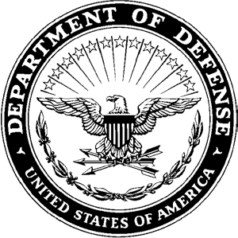
DEPARTMENT OF THE ARMY
HEADQUARTERS, AIRBORNE and RANGER TRAINING BRIGADE 10850 SCHNEIDER ROAD
FORT MOORE, GEORGIA 31905-5000

ATSH-RB 16 January 2025

MEMORANDUM FOR Airborne and Ranger Training Brigade

SUBJECT: [INSERT UNIT] Competitors for the 41st Annual LTG(R) David E. Grange Jr. Best Ranger Competition

- The Soldiers listed below have been assessed and selected by the Commander to represent the [INSERT UNIT] in the 41st Annual LTG (R) David E. Grange Jr. Best Ranger Competition:

  - Team 1

    - RANK last, name, first name (DODID)
    - RANK last, name, first name (DODID)

  - Team 2

    - RANK last, name, first name (DODID)
    - RANK last, name, first name (DODID)

- The Soldier listed above have successfully complete a unit assessment that included the following events:

  - Ranger Physical Assessment
  - 12-mile foot march in 3 hours with a minimum of 35lb rucksack, not including water weight.
  - Combat water survival assessment consisting of a 15-meter swim in ACUs and boots.
  - Basic Rifle Marksmanship
  - Tactical Combat Casualty Care (TCCC)

- The POC for this memorandum is the [INSERT DIV G3 (or BDE S3 if the unit is a separate BDE) POC information].

NAME
RANK, BRANCH
POSITION

17 February 2025 | Letter of Intent Due
28 February 2025 | Competitor Packet Due
07 March 2025 | ARTB releases by-name team list
11 March 2025 | No Further Training on ARTB sites
April 2025 | Competitor Report Date
07-10 April 2025 | Competitor Week
11-13 April 2025 | Competition
14 April 2025 | Award Ceremony

